What can project 5 do?

My program obeys all of the specifications given with the project. In addition, I do not assume that user enters all of the names correctly, i.e different than the others. Program checks the name when user enters “exists” or “beget” command and warns user if a person with same name exists. Also, as stated in the mail, a person can not be married with his/her parents, grandparents, aunts, uncles and siblings.

I created following families in my program. Commands are in the “Family.trn” file which I gave with my source code. In addition, I gave the “Family.dat” file which contains this family tree. Program can be tested with this diagram.

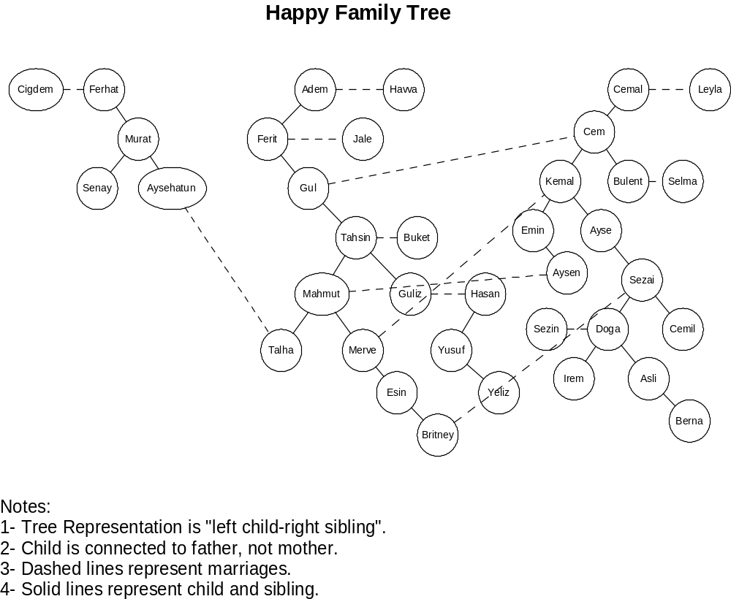

Emin Şenay
2002103907

